L09 Participation Assignment – Super Class

Background
Implement a simple class

Procedure
Answer the following questions with cut and paste or screenshots.

- Implement the code below. To avoid duplication in the __init__ for Ebok, replace the duplicated sub class defintions in Ebook with a super() class. Show your code:
# oop/super.duplication.py
class Book:
def __init__(self, title, publisher, pages):
self.title = title
self.publisher = publisher
self.pages = pages

class Ebook(Book):
def __init__(self, title, publisher, pages, format_):
self.title = title
self.publisher = publisher
self.pages = pages
self.format_ = format_

ebook = Ebook(
'Learn Python Programming', 'Packt Publishing', 500, 'PDF')
print(ebook.title)
print(ebook.publisher)
print(ebook.pages)
print(ebook.format_)
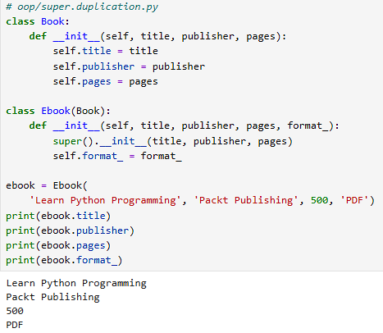

- Usie the dunder method with __str__ to convert the object to string and make it human readable. This is used for creating a user-friendly output and dsiplaying the object as a string.
Use this code:

class Ocean:

def __init__(self, sea_creature_name, sea_creature_size):
self.name = sea_creature_name
self.size = sea_creature_size

# placeholder

# another placeholder

c = Ocean('Jellyfish', '30 cm')

Add this string method to the function at the placeholder:
def __str__(self):
return f'The creature type is {self.name} and the age is {self.size}'

Now print it:
print(str(c))

Show your output:
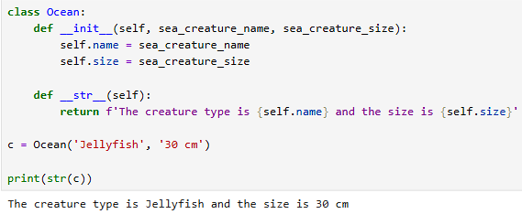

- Use the Ocean class and add another dunder method as __repr__. This is used to return a string object typically for debugging and development testing purposes.

Add this rpr method to the function at the placeholder:
def __repr__(self):
return f'Ocean(\'{self.name}\', {self.size})'

Then print it:
print(repr(c))

Show your output:
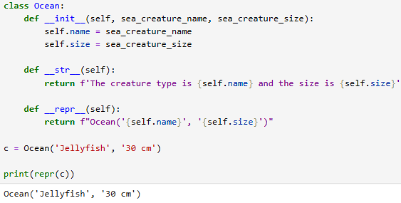

- Copy the code below:

# some_inheritance.py
class Engine:
def start(self):
return
def stop(self):
pass
class ElectricEngine(Engine): # Is-A Engine
pass
class V8Engine(Engine): # Is-A Engine
pass

class Car:
engine_cls = Engine
def __init__(self):
self.engine = self.engine_cls() # Has-A Engine
def start(self):
print(
'Starting engine {0} for car {1}... Wroom, wroom!'
.format(
self.engine.__class__.__name__,
self.__class__.__name__)
)
self.engine.start()
def stop(self):
self.engine.stop()
class RaceCar(Car): # Is-A Car
engine_cls = V8Engine
class CityCar(Car): # Is-A Car
engine_cls = ElectricEngine
class F1Car(RaceCar): # Is-A RaceCar and also Is-A Car
pass # engine_cls same as parent
car = Car()
racecar = RaceCar()
citycar = CityCar()
f1car = F1Car()
cars = [car, racecar, citycar, f1car]
for car in cars:
car.start()

Compose a Headlights Class is in a HAS-A relationship with Car. Implement this into Car.
class Headlights:
def lights_on(self):
print('Lights are on')

def lights_off(self):
print('lights are off')

Paste the revised code and output below:
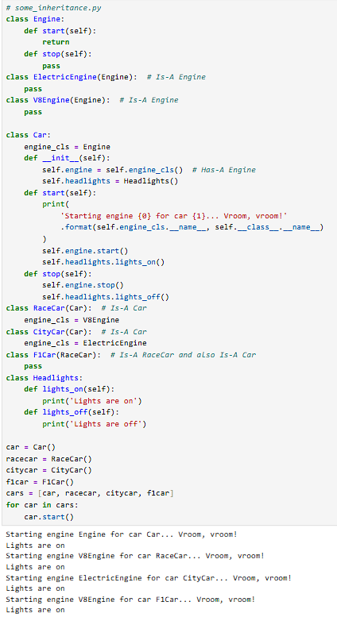

- Submit this word document to Canvas. Use copy and paste or screenshots for the answers. Questions should be included to use as a study guide.

